

Automation Technology 1

Lab 2: Basic Ladder Logic Design with Timers
Lecturer: Eoin Byrne
Submission Date: 30/10/2026
Student Name: David Roberto Tapia Caicedo

Section 1 – Introduction to Simple Ladder Diagrams

Abstract:
The aim of this section is to familiarise students with basic timer functions alongside operations and the programming of a simple ladder diagrams. Students will download their programs to the Mitsubishi FX3G PLC, test, and verify their programs to ensure satisfactory operation.

Objective:
To gain practical experience constructing ladder diagrams and programming a PLC using timers for outputs for various Scenarios.

Automation Problem 1:

Using GX Works 2 design a ladder logic program on which lamp Y0 turns on immediately when button X0 is pressed. The lamp Y0 should only be turned on for 10 seconds and then turn off. The Lamp Y0 should only be turned for 10 seconds, even if push button S1 is held longer than 10 seconds

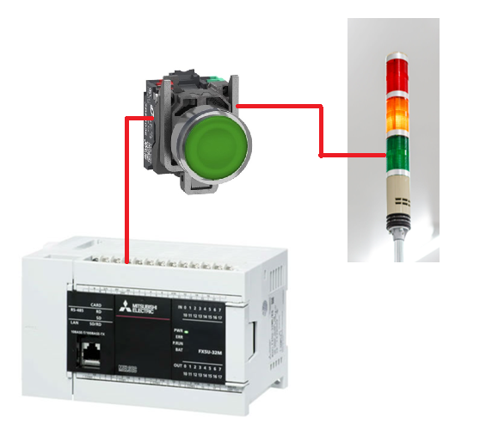

1: Design the Ladder Logic
2: Test on Simulator to ensure correct Operation
3: Download to PLC to Verify correct Operation
4: Screen Shot of ladder Diagram explaining Operation

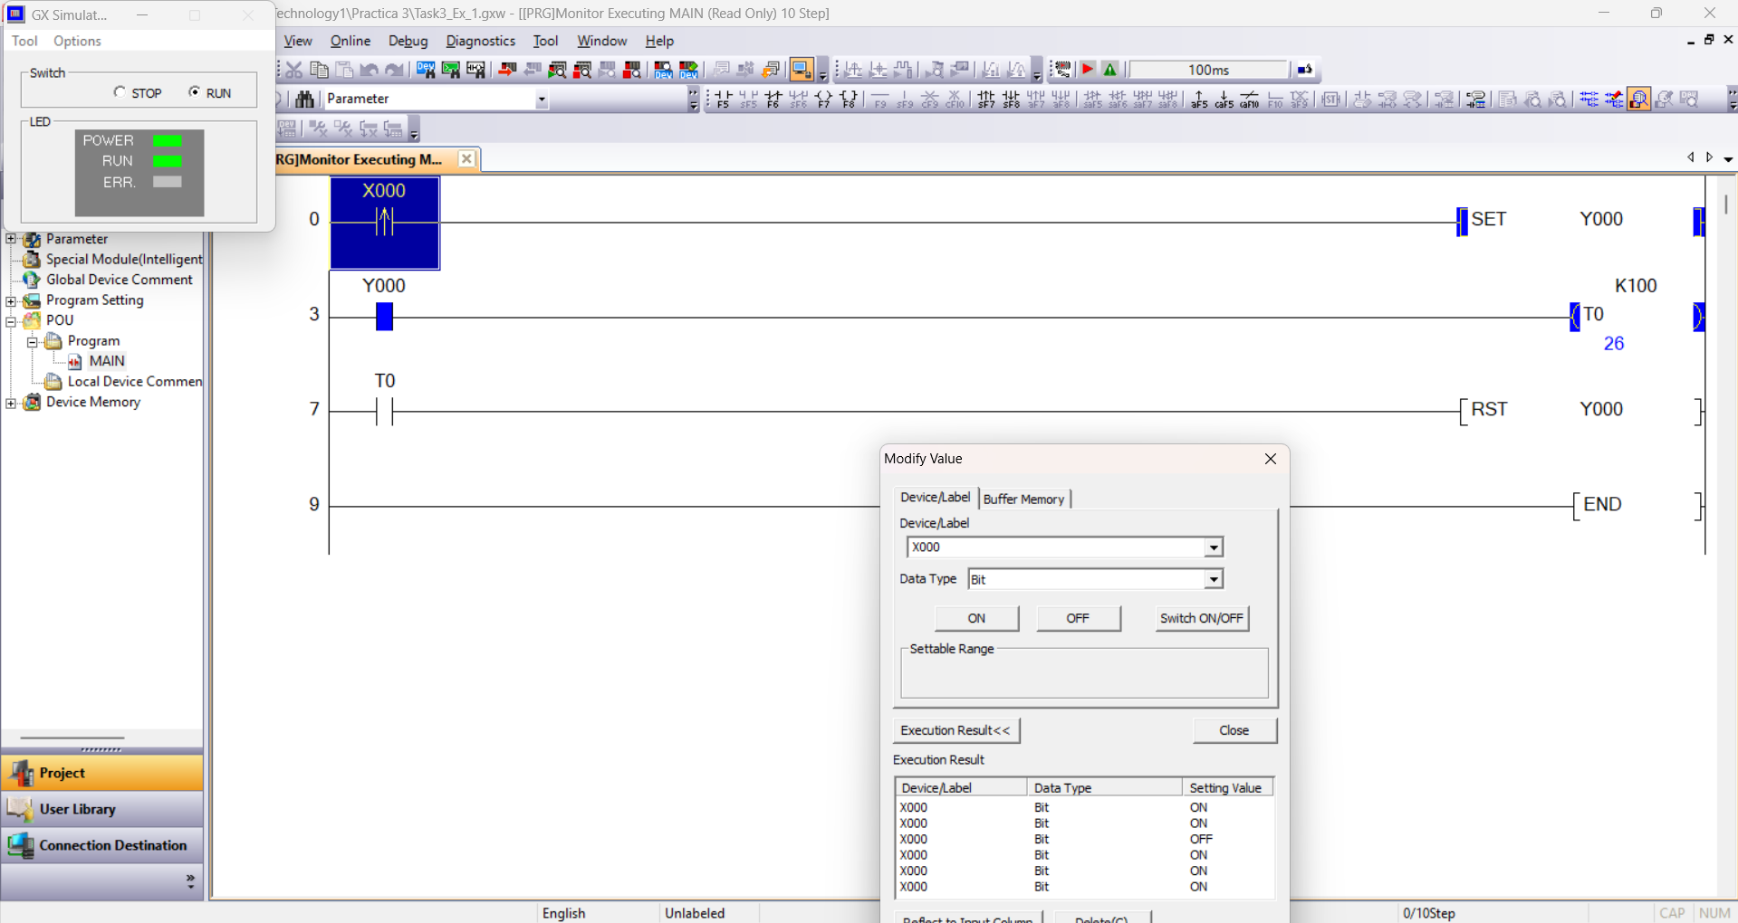
Figure 1: Exercise 1 Test

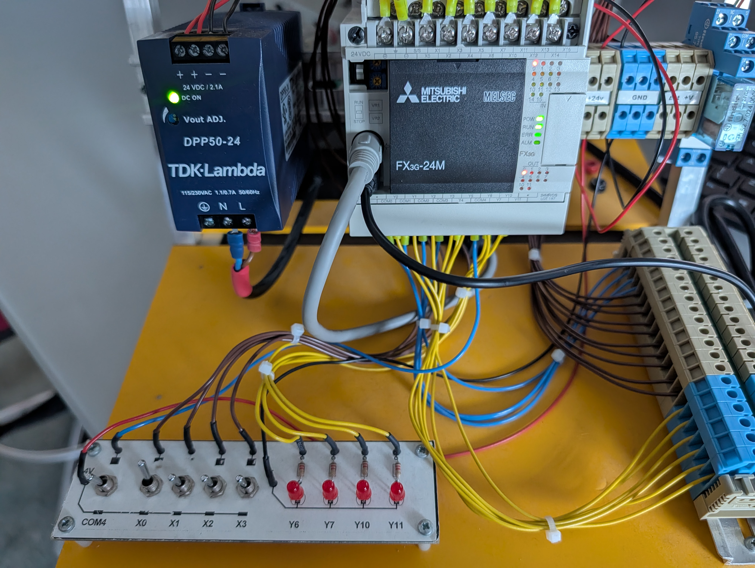
Figure 2: X0 active and Y0 active for 10 seconds
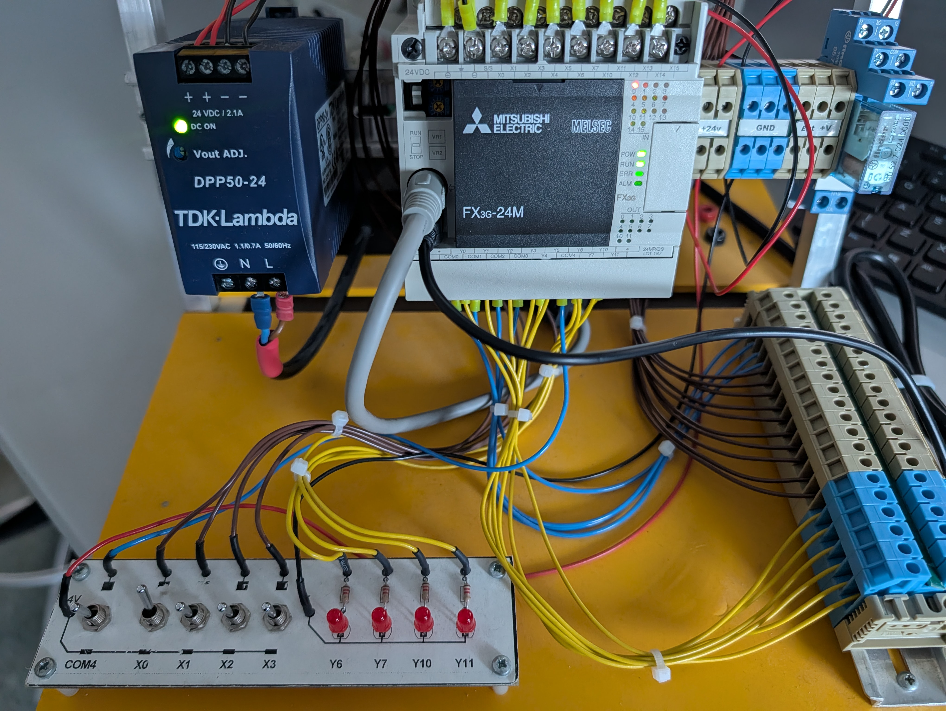
Figure 3: X0 active after 10 seconds but Y0 not
Line 0: Input X0 is configured as a rising-edge pulse contact connected to the SET Y0 instruction. When pushbutton X000 is pressed, this contact only allows power to pass for a single scan cycle on the rising edge. This momentary pulse sets and latches lamp Y0 on immediately. Because X0 only triggers on the rising edge, holding the button down for more than 10 seconds will not keep sending power to the SET instruction.
Line 3: A NO contact of Y0 is connected to timer T0 with a preset value of 100. While lamp Y0 is latched ON, its contact stays closed and powers T0 continuously so it counts up to 100.
Line 7: A Normally Open contact of timer T0 is connected to the RST Y0 instruction. Once 10 seconds have passed, T0 reaches K100 and closes its contact, which resets Y0 and turns the lamp OFF. When Y000 turns off, its contact in line 3 opens, removing power from T0 and resetting the timer back to 0 automatically.

Automation Problem 2:

Design a PLC Program to meet the following System Requirements. When button X0 is pressed, the lights should alternate as follows in the warning lamps. First Y0 turns on. Y0 turns off, Y1 turns on. Y1 turns off, Y2 turns on. Y2 turns off, Y3 turns on. Y3 turns off and then Y0 turns back on again and the sequence repeats. A lamp should only be in for 2 Seconds.

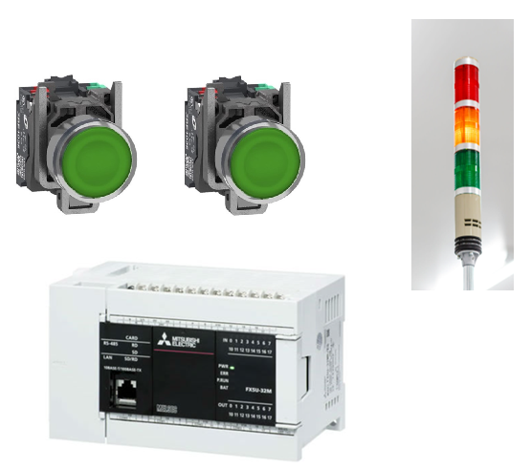
1: Design the Ladder Logic
2: Test on Simulator to ensure correct Operation
3: Download to PLC to Verify correct Operation
4: Screen Shot of ladder Diagram explaining Operation

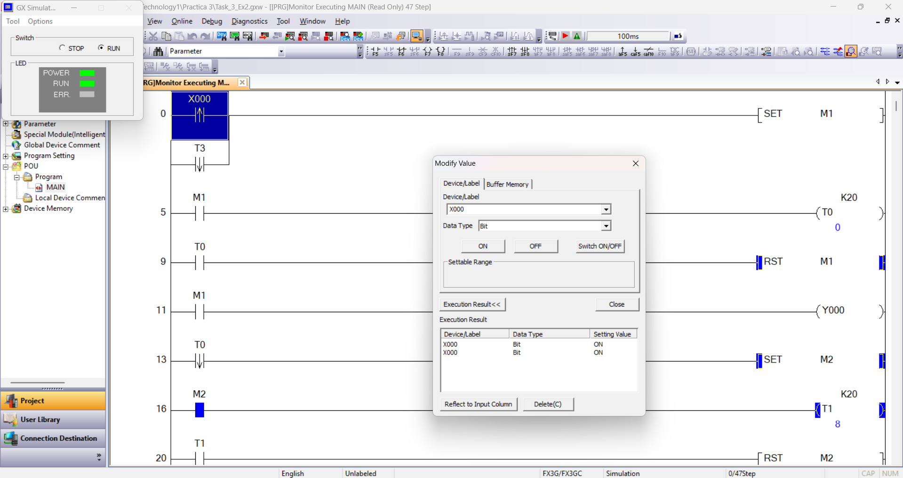
Figure 4: Exercise 2 Test
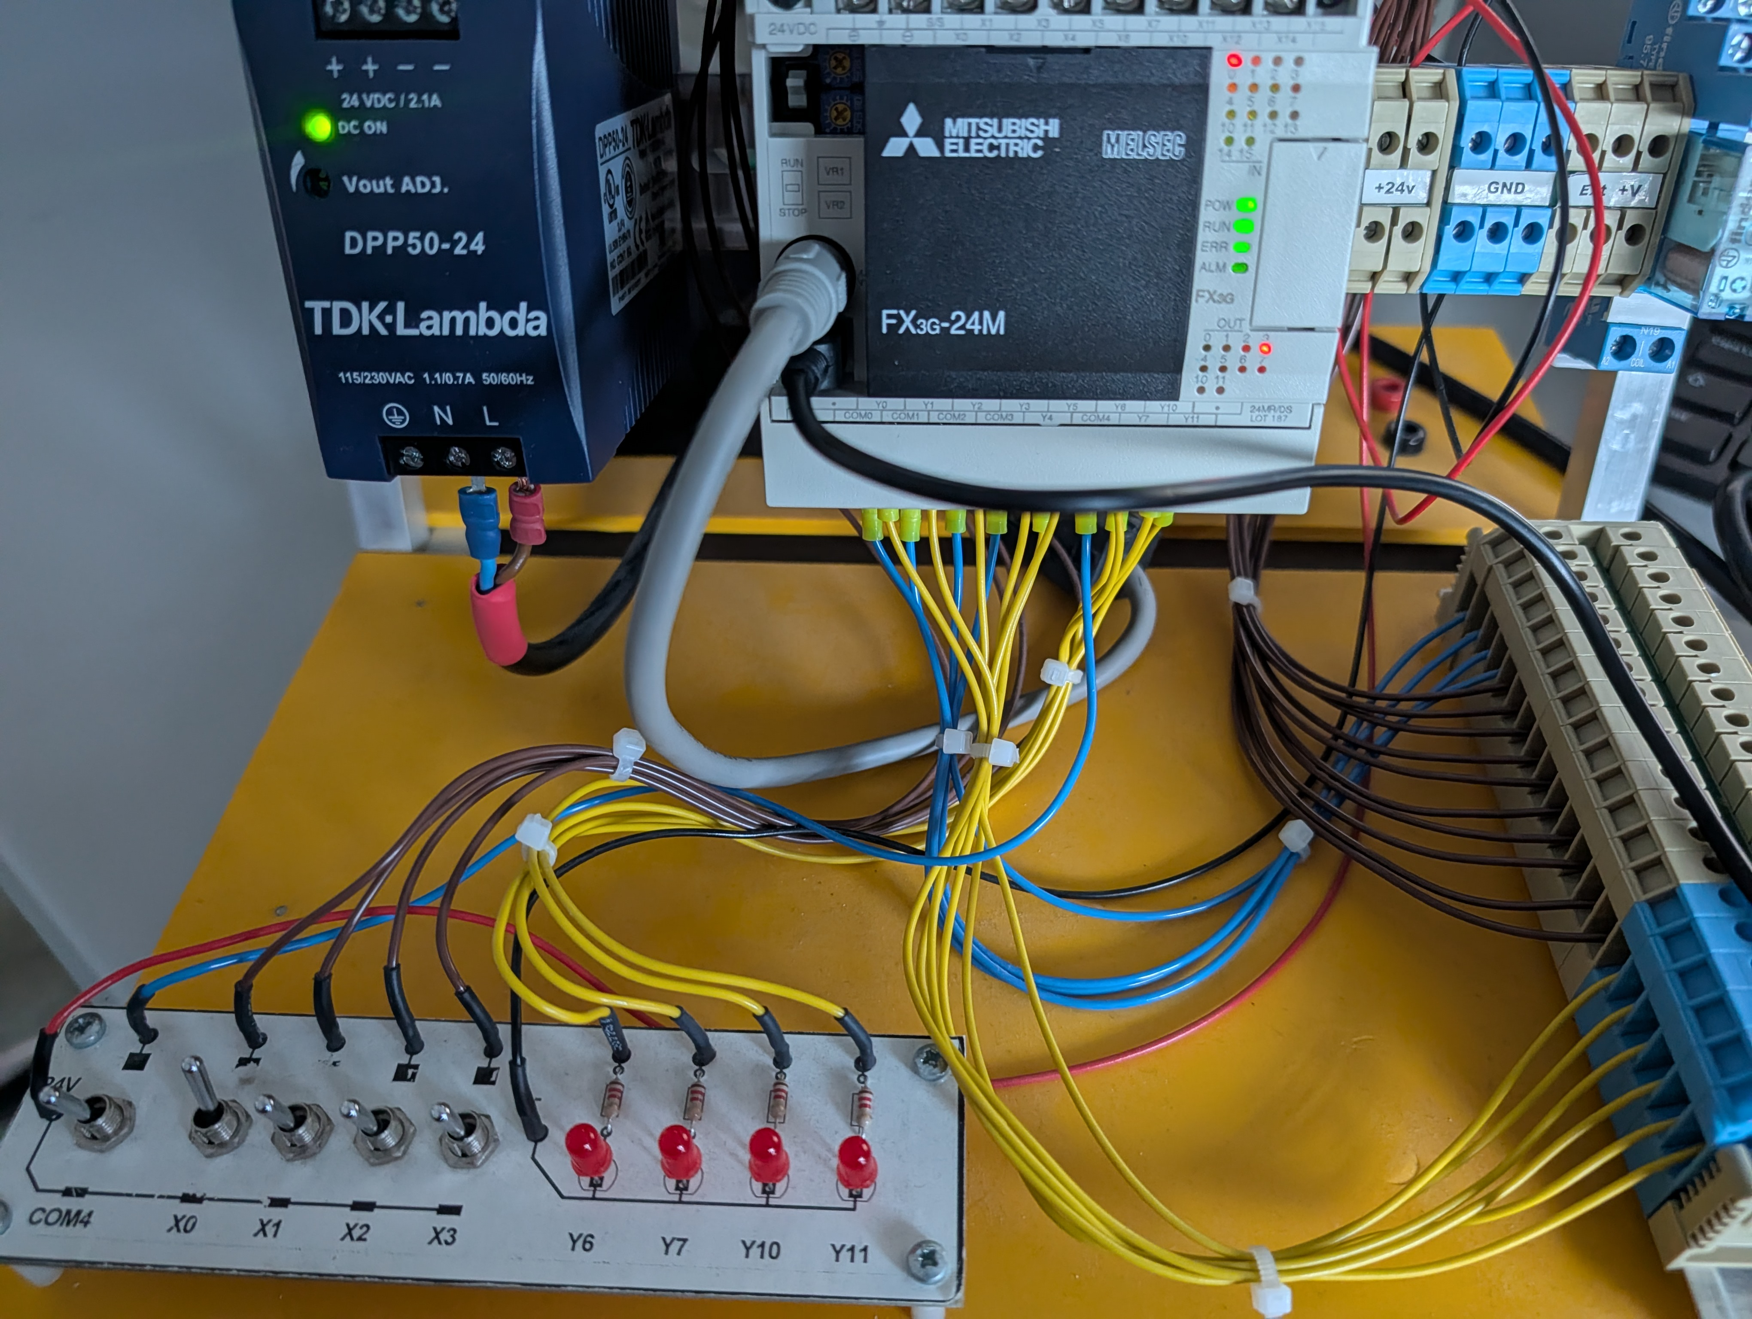
Figure 5: X0 active to start the lamps count
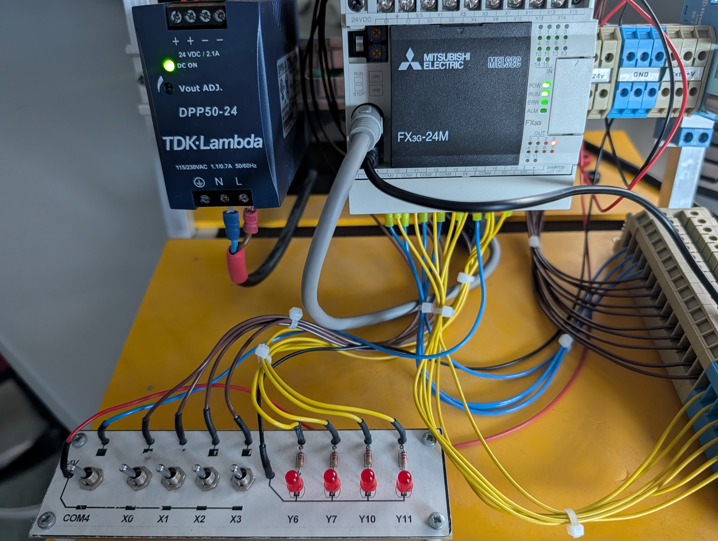
Figure 6: The count continues even with X0 not active
Line 0: Input X0 and timer T3 are placed in parallel to trigger SET M1. Pressing X0 starts the first stage, M1, manually, while the falling edge of the last timer, T3, sets M1 again at the end of the fourth lamp cycle so the sequence loops forever without pressing X000 again.
Lines 5 to 11: First Stage
- Line 5: When M1 is active, its NO contact powers timer T0 with a preset of K20, 2 seconds.
- Line 9: Once T0 reaches 2 seconds, its NO contact closes and executes RST M1, turning M1 and T0 off.
- Line 11: A NO contact of M1 powers output coil Y0, keeping the first lamp ON during the 2 seconds that M1 is active.
Line 13: A falling-edge pulse contact of timer T0 is connected to SET M2. At the exact moment M1 is reset and T0 drops from ON to OFF, this falling edge triggers SET M2 to start the second lamp stage.
Lines 16 to 46: The remaining lines repeat the exact same 4-rung structure used in first stage only changing the internal relay, timer, and output addresses for each 2 second step:
- Stage 2: M2 powers timer T1 and turns on lamp Y1 for 2 seconds. When T1 finishes, it resets M2 and its falling edge triggers SET M3.
- Stage 3: M3 powers timer T2 and turns on lamp Y2 for 2 seconds. When T2 finishes, it resets M3 and its falling edge triggers SET M4.
- Stage 4: M4 powers timer T3 and turns on lamp Y3 for 2 seconds. When T3 reaches K20, it triggers RST M4. As T3 turns off, its falling-edge contact in line 0 activates SET M1, restarting the entire sequence from Y000 automatically.

Automation Problem 3:

In the following exercise, you must design a ladder logic PLC program for controlling a traffic signal at a pedestrian crossing field, as per the following illustration.
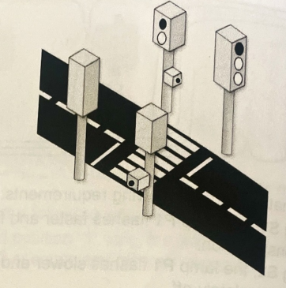
. The two buttons named S1 and S2. The person may only cross the road when there is a red light for vehicles and a green light for people walking. The sequence for the traffic signal can be divided into the six steps below.
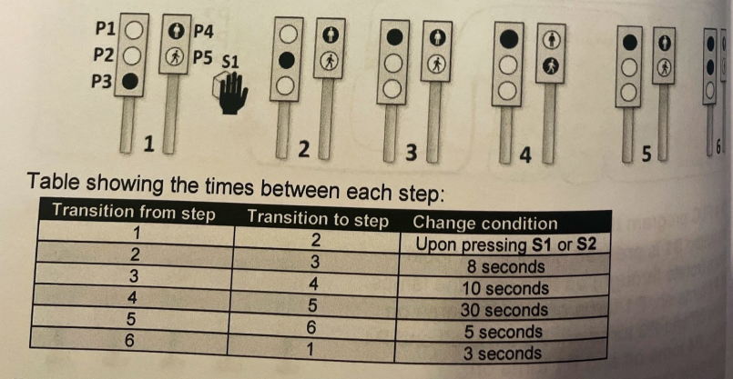
1: Develop and I/0 table for the process.
2: Design the Ladder Logic
3: Test on Simulator to ensure correct Operation
4: Download to PLC to Verify correct Operation
5: Screen Shot of ladder Diagram explaining Operation and how states and transitions are achieved using data registers
( 50 Marks)

Symbols | PLC Address | I/O | Description
S1 | X0 | Input | Pedestrian push button 1
S2 | X1 | Input | Pedestrian push button 2
P1 | Y0 | Output | Red Light
P2 | Y1 | Output | Amber Light
P3 | Y2 | Output | Green Light
P4 | Y3 | Output | Pedestrian Red Light
P5 | Y4 | Output | Pedestrian Green Light

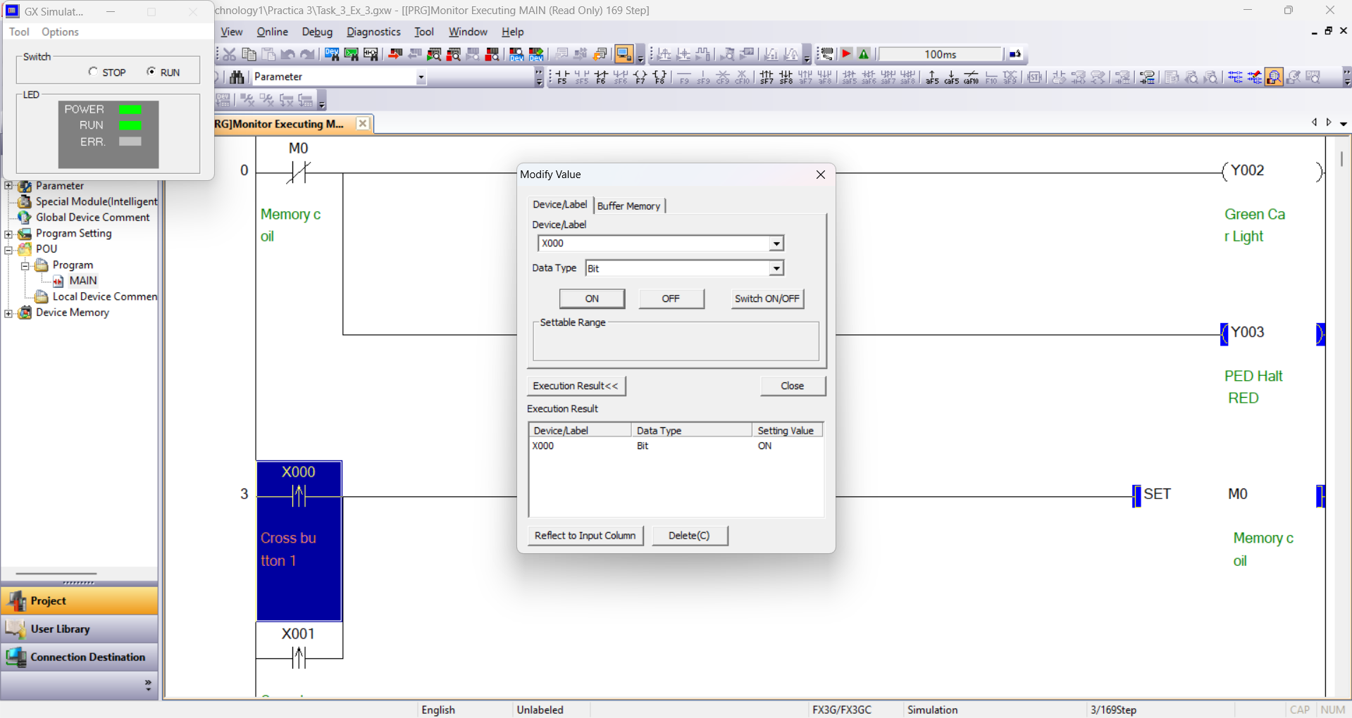
Figure 7: Exercise 3 Test
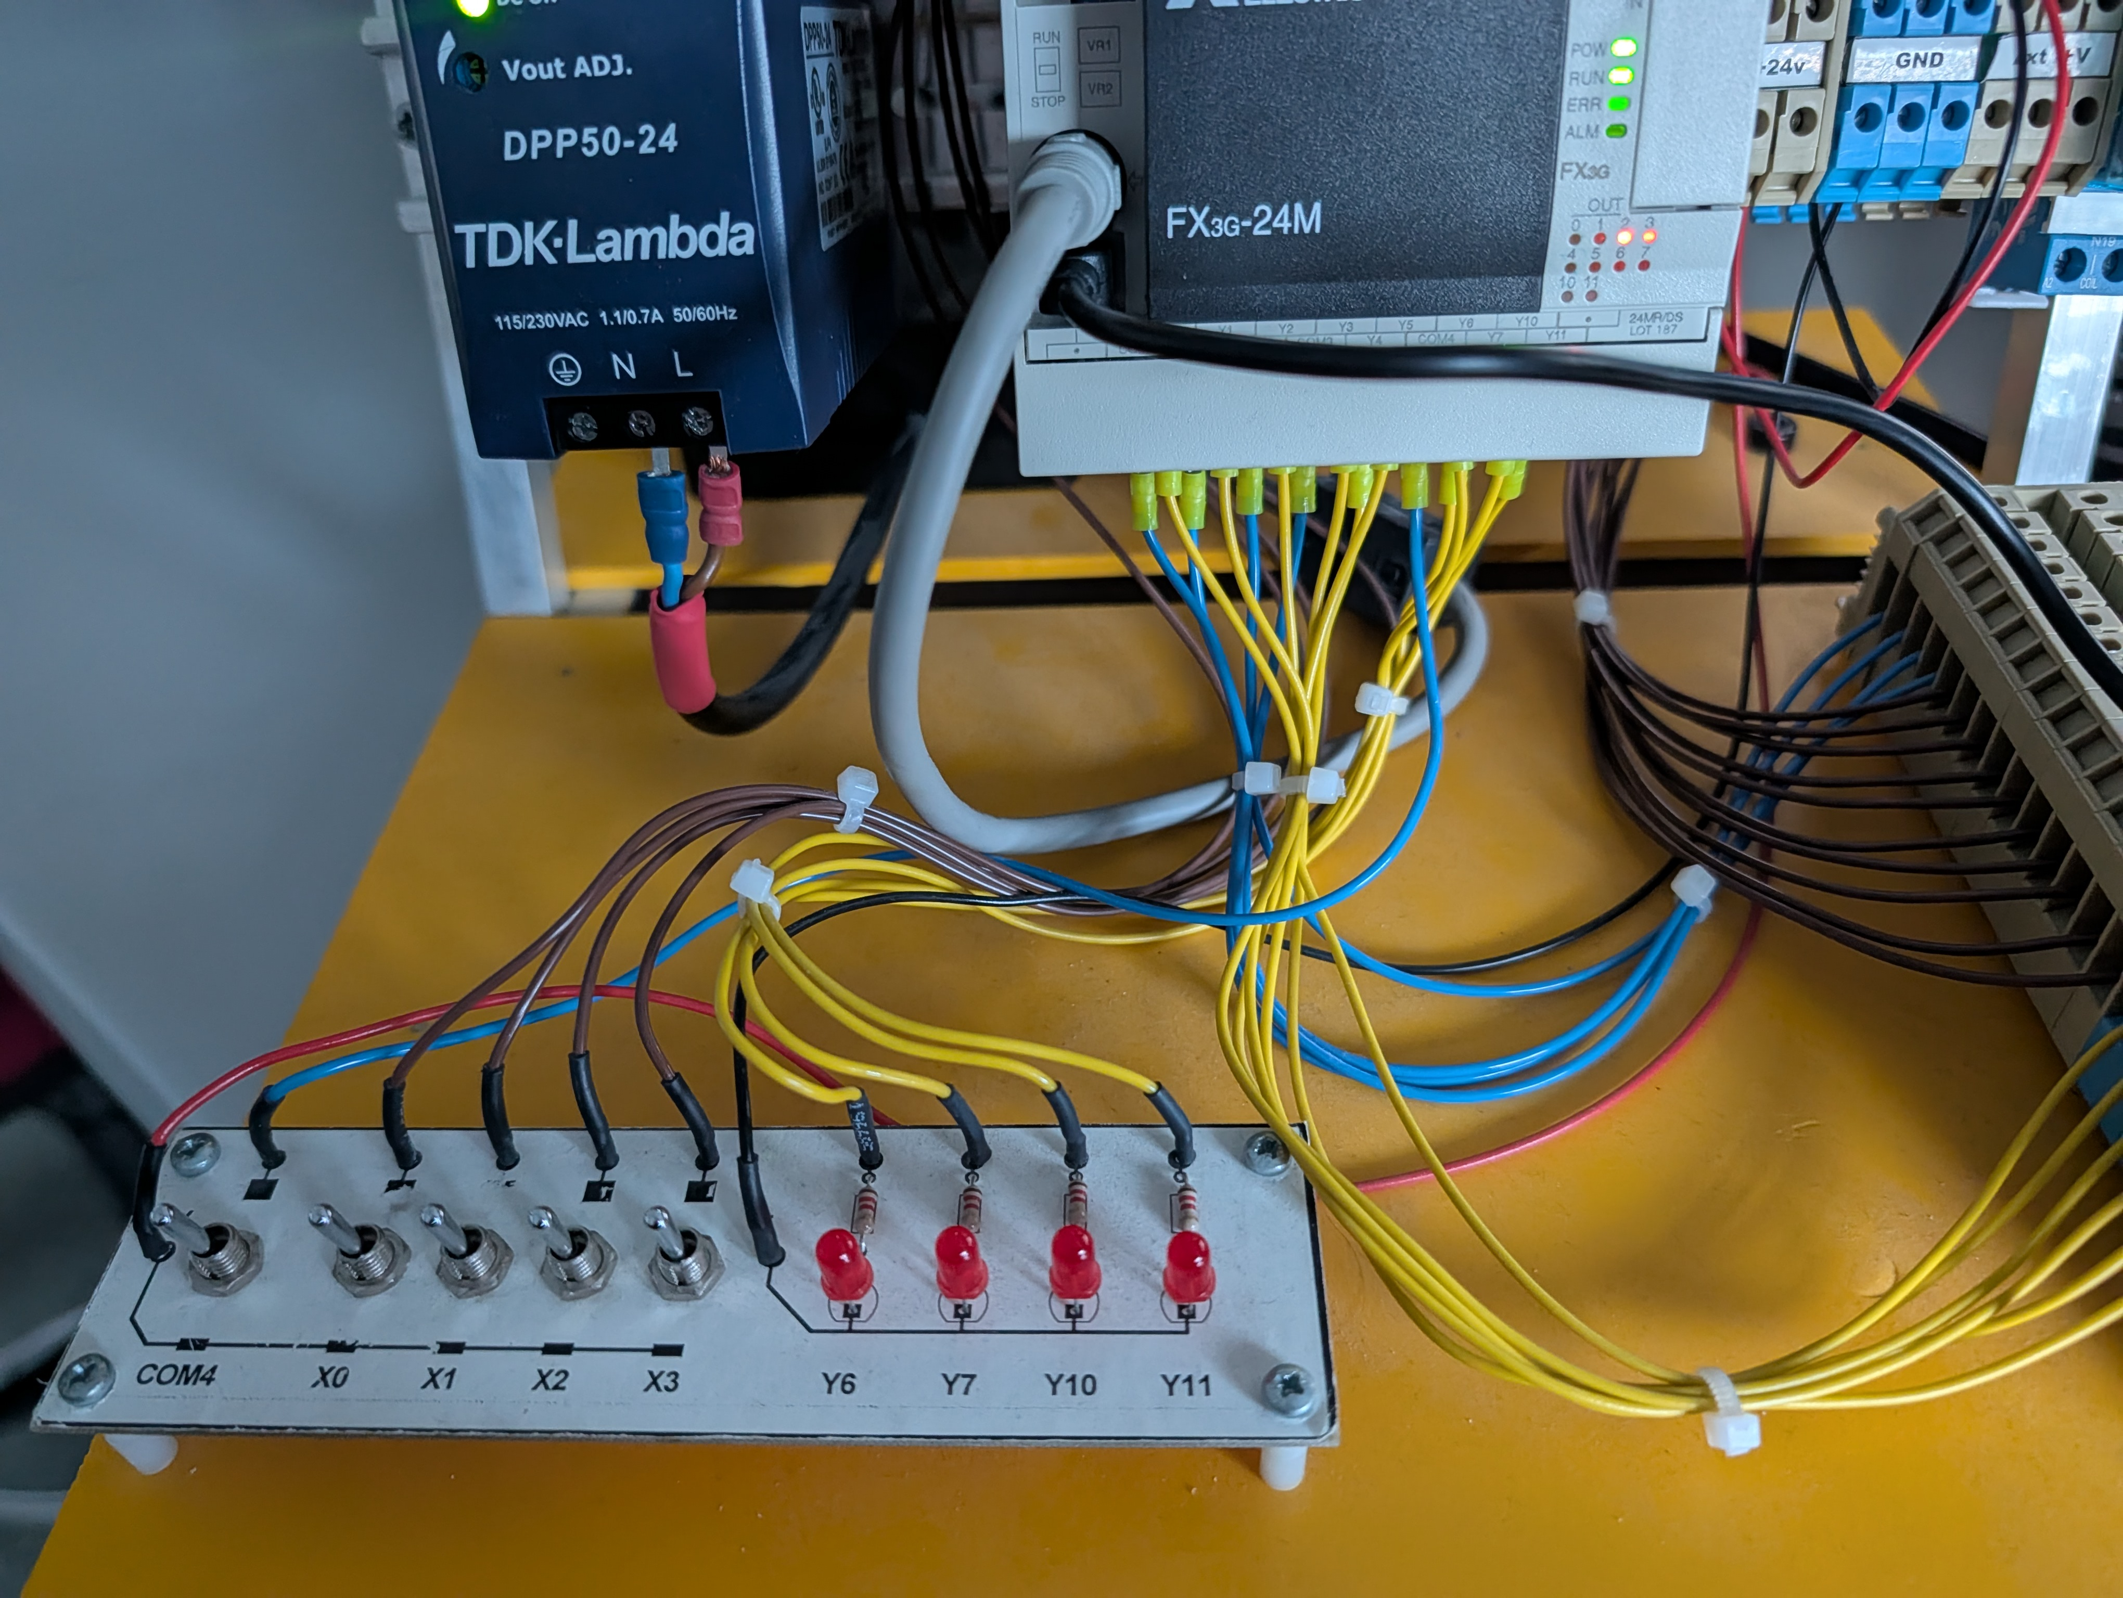
Figure 8: Initial state, green car light and red pedestrian light
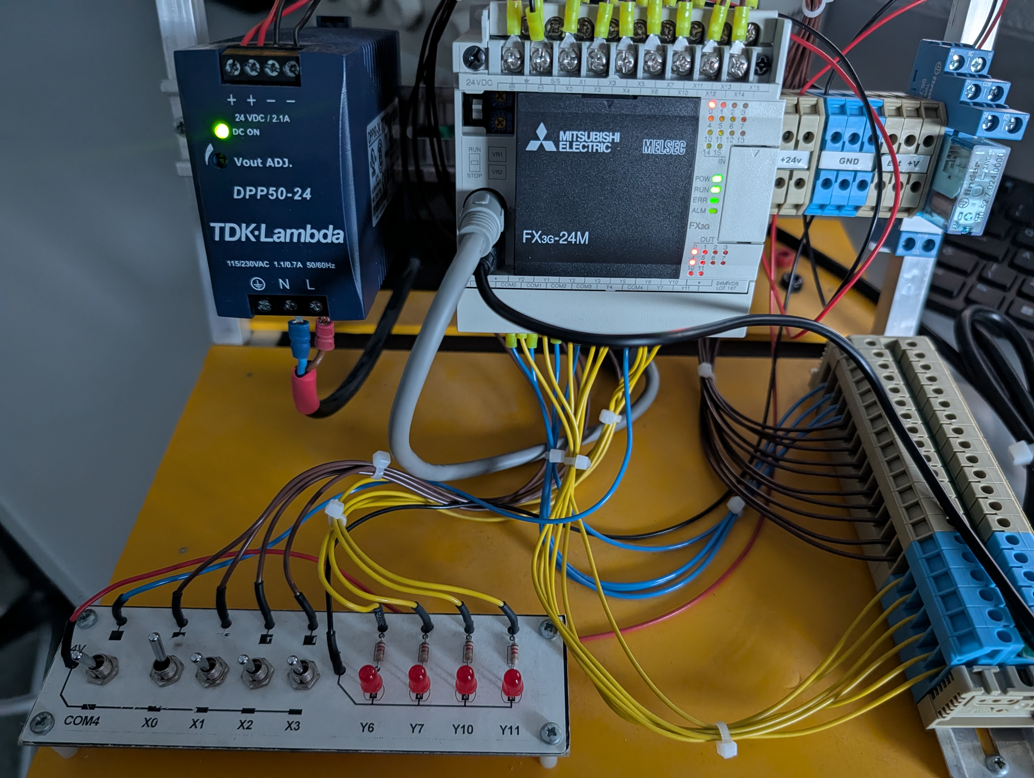
Figure 9: After 18 seconds, red car light and green pedestrian light

States and Transitions Logic
Instead of using multiple individual internal relays to track each step, this program uses Data Register, D0, as a state machine variable.
- Setting States [MOV Kx D0]: The MOV instruction moves a constant integer, K1 to K6, into data register D0 to represent which of the 6 traffic light steps is currently active.
- Reading States [= D0 Kx]: In-line comparison instructions (= D0 K1, = D0 K2, etc.) check the current number stored inside D0. When the value in D0 matches the constant Kx, the comparison contact acts as a closed switch enabling the timer and the specific traffic light outputs required for that step.

Line-by-Line explanation:
Line 0 (Initial State): Before any button is pressed, memory coil M0 is off, so its Normally Closed contact in line 0 lets power pass to turn on Y002 (Green Car Light) and Y003 (Pedestrian Red Light) by default.
Transition from Step 1 to Step 2: When the system is in Step 1 and a pedestrian presses either pushbutton S1 (X0) OR S2 (X1), the rung executes [MOV K2 D0]. This overwrites D0 with the value 2, immediately transitioning the system to Step 2.
Step 2 to Step 6 Timed Transitions: Steps 2 through 6 follow the exact same ladder structure, changing only the state number being compared (= D0 Kx), the timer address and preset time (Tx Kx), and the next state number moved into D0:
- Step 2: When [= D0 K2] is true, it powers timer T0. Once 8 seconds pass, T0 closes its contact and executes [MOV K3 D0], advancing the state to Step 3.
- Step 3: When [= D0 K3] is true, it powers timer T1. After 10 seconds, T1 executes [MOV K4 D0] to transition to Step 4.
- Step 4: When [= D0 K4] is true, it powers timer T2. After 30 seconds of green walking time, T2 executes [MOV K5 D0] to move to Step 5.
- Step 5: When [= D0 K5] is true, it powers timer T3. After 5 seconds elapse, T3 executes [MOV K6 D0] to enter Step 6.
- Step 6: When [= D0 K6] is true, it powers timer T4. Once the 3 seconds finish, T4 executes [MOV K1 D0], returning the traffic signal back to Step 1 and waiting for the next pedestrian button press.

Output Control Rungs
At the bottom of the program, each physical lamp coil is energized in a single rung using parallel branches of the states where that specific light must be ON according to the sequence table:
- Y0: Turned ON when D0 is in Step 3, Step 4, Step 5, or Step 6.
- Y1: Turned ON when D0 is in Step 2 or Step 6.
- Y2: Turned ON only when D0 is in Step 1.
- Y3: Turned ON when D0 is in Step 1, Step 2, Step 3, Step 5, or Step 6.
- Y4: Turned ON only when D0 is in Step 4.

Conclusion
During this laboratory practice, we learned how to design, simulate, and test timer on Mitsubishi FX3G PLC using GX Works2. In Problem 1, combining a rising edge pulse contact with SET and RST instructions ensured that the output lamp only stayed on for the exact 10-second duration of timer T0 (K100), preventing the circuit from retriggering if the start button was held down. In Problem 2, internal relays, M1 to M4, and falling edge timer contacts were used to build a continuous 2 second chaser loop across four warning lamps. Finally, Problem 3 showed how to program a longer 6-step pedestrian crossing sequence by combining memory bits, timers, and data register D0 with MOV and comparison instructions. Using data registers to track each step makes a multi-step program much cleaner and easier to follow than using a large number of normal relay contacts.

